**COMP 440 FINAL PROJECT REPORT HARISH PINDI**

**Stored Procedures**

**1)Stored Procedure-1(INSERTION)**

**For feature Insertion**

USE [s16guest04]

GO

/****** Object: StoredProcedure [dbo].[feature_data] Script Date: 5/2/2016 10:40:50 AM ******/

SET ANSI_NULLS ON

GO

SET QUOTED_IDENTIFIER ON

GO

create PROCEDURE [dbo].[feature_data]

@feature_id int ,

@feature_name varchar(50),

@feature_description varchar(80)

AS

BEGIN

Begin Try

SET NOCOUNT ON

Begin Transaction

INSERT INTO [dbo].[feature]

([feature_id],

[feature_name],

[feature_description]

)

VALUES

(

@feature_id ,

@feature_name,

@feature_description

)

Commit Transaction

End Try

Begin Catch

Rollback Transaction

Select

ERROR_NUMBER() as ErrorNumber,

ERROR_MESSAGE() as ErrorMessage,

ERROR_PROCEDURE() as ErrorProcedure,

ERROR_STATE() as ErrorState,

ERROR_SEVERITY() as ErrorSeverity,

ERROR_LINE() as ErrorLine

END Catch

END

**Before insertion of feature data**

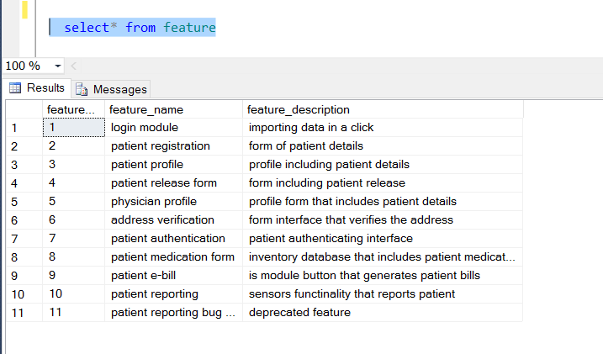

**After insertion of a record in to a feature table by means of stored procedure**

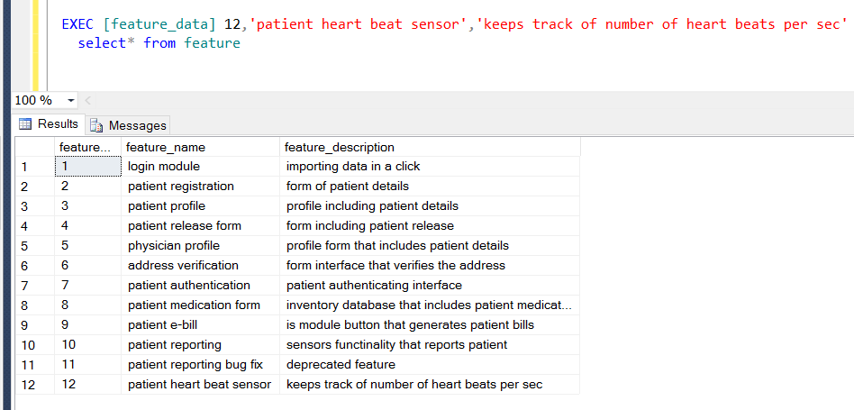

**Displaying error message while inserting duplicate data**

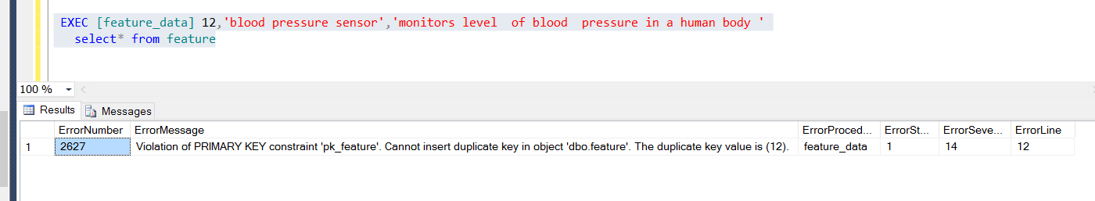

**2. Update product version stored procedure**

Here in these when ever product gets updated its version gets updated corresponding to its version id

**Code:**

/****** Object: StoredProcedure [dbo].[sp_product_version] Script Date: 5/2/2016 3:13:15 PM ******/

SET ANSI_NULLS ON

GO

SET QUOTED_IDENTIFIER ON

GO

CREATE procedure [dbo].[sp_product_version]

--declaring the product attributes and version attributes

@product_id int,

@product_name varchar(50),

@version_id int,

@version_name varchar(90)

AS

BEGIN

Begin Try

SET NOCOUNT ON

Begin Transaction

----Updating the product table A by means of inner join with version table B

update A

set A.product_name= @product_name

from product A inner join version B

on B.product_id = A.product_id

and A.product_id = @product_id

----Updating the version table B by means of inner join with product table A

update B

set B.version_name = @version_name,B.version_id=@version_id

from version B inner join product A

on B.product_id = A.product_id

and A.product_id = @product_id

Commit Transaction

End Try

Begin Catch

Rollback Transaction

Select

ERROR_NUMBER() as ErrorNumber,

ERROR_MESSAGE() as ErrorMessage ,

ERROR_PROCEDURE() as ErrorProcedure,

ERROR_STATE() as ErrorState,

ERROR_SEVERITY() as ErrorSeverity,

ERROR_LINE() as ErrorLine

END Catch

END

GO

**Before the stored procedure**

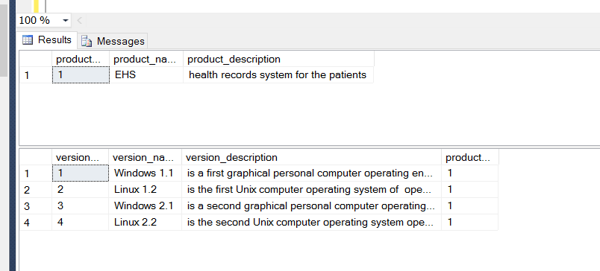

**After the update stored procedure**

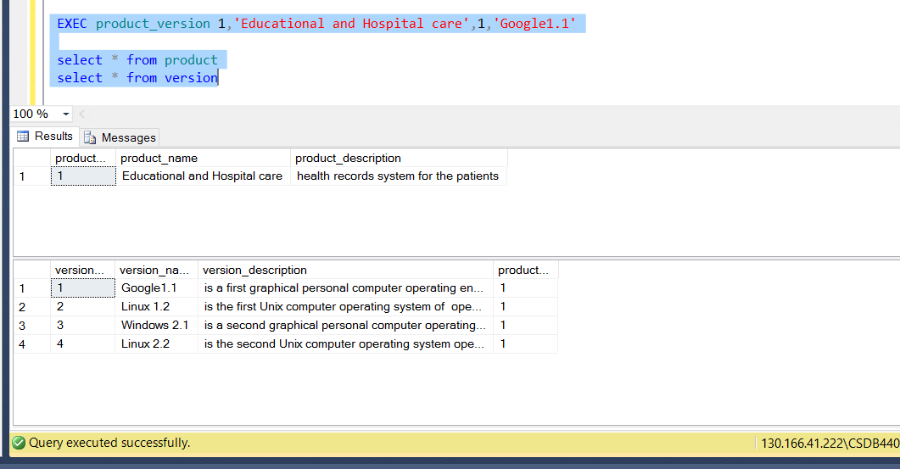

**3) Download Report Stored procedure**

USE [s16guest04]

GO

/****** Object: StoredProcedure [dbo].[download_report] Script Date: 5/2/2016 3:36:36 PM ******/

SET ANSI_NULLS ON

GO

SET QUOTED_IDENTIFIER ON

GO

create procedure [dbo].[download_report]

AS

BEGIN

Begin Try

SET NOCOUNT ON

Begin Transaction

select [product_name],

[version_name],

--here below the month of download date is so called as Month

MONTH(download_date) AS [Month],

---For counting the number of months in a date we use count operation

COUNT(MONTH(download_date)) AS [Count]

FROM version

INNER JOIN customer_download

ON version.version_id=customer_download.downloaded_version

INNER JOIN product

ON product.product_id=version.product_id

---the records for a particular manner to display we use group by

GROUP BY [product_name],[version_name],MONTH(download_date)

Commit Transaction

End Try

Begin Catch

Rollback Transaction

Select

ERROR_NUMBER() as ErrorNumber,

ERROR_MESSAGE() as ErrorMessage ,

ERROR_PROCEDURE() as ErrorProcedure,

ERROR_STATE() as ErrorState,

ERROR_SEVERITY() as ErrorSeverity,

ERROR_LINE() as ErrorLine

END Catch

END

GO

**After executing the stored procedure**

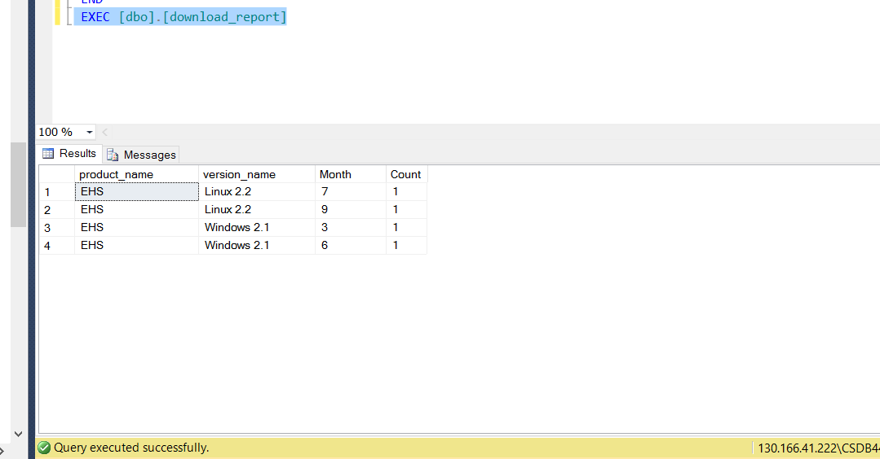

4)Feature report stored procedure

/****** Object: StoredProcedure [dbo].[feature_report] Script Date: 5/2/2016 11:34:27 PM ******/

SET ANSI_NULLS ON

GO

SET QUOTED_IDENTIFIER ON

GO

CREATE procedure [dbo].[feature_report]

@version_name varchar(90),

@release_name varchar(20)

AS

Begin

----retrieving the number of new features for the particular version by using inner join between version and feature by means of cross reference table Version_feature

declare @result int

SELECT @result=COUNT (feature_name )

FROM version_feature

INNER JOIN feature

ON version_feature.feature_id=feature.feature_id

INNER JOIN version

ON version_feature.version_id=version.version_id

WHERE version_name = @version_name

if(@result<>0)

print 'For '++ @version_name ++ ',There are '++ CAST(@result AS VARCHAR) ++ ' new features';

else

print 'There are bugs'

declare @Fresult int;

----retrieving the number of new features for particular release by using inner join between development_release and feature by means of cross reference table release_feature

SELECT @Fresult=COUNT (feature_name )

FROM release_feature

INNER JOIN feature

ON release_feature.feature_id=feature.feature_id

INNER JOIN [development_release]

ON release_feature.release_id=development_release.release_id

WHERE release_name = @release_name

if(@Fresult<>0)

print 'There are '+ CAST(@result AS VARCHAR) + 'new features for' ++ @release_name ++' release' ;

else

print 'It is a bug-fix release'

END

GO

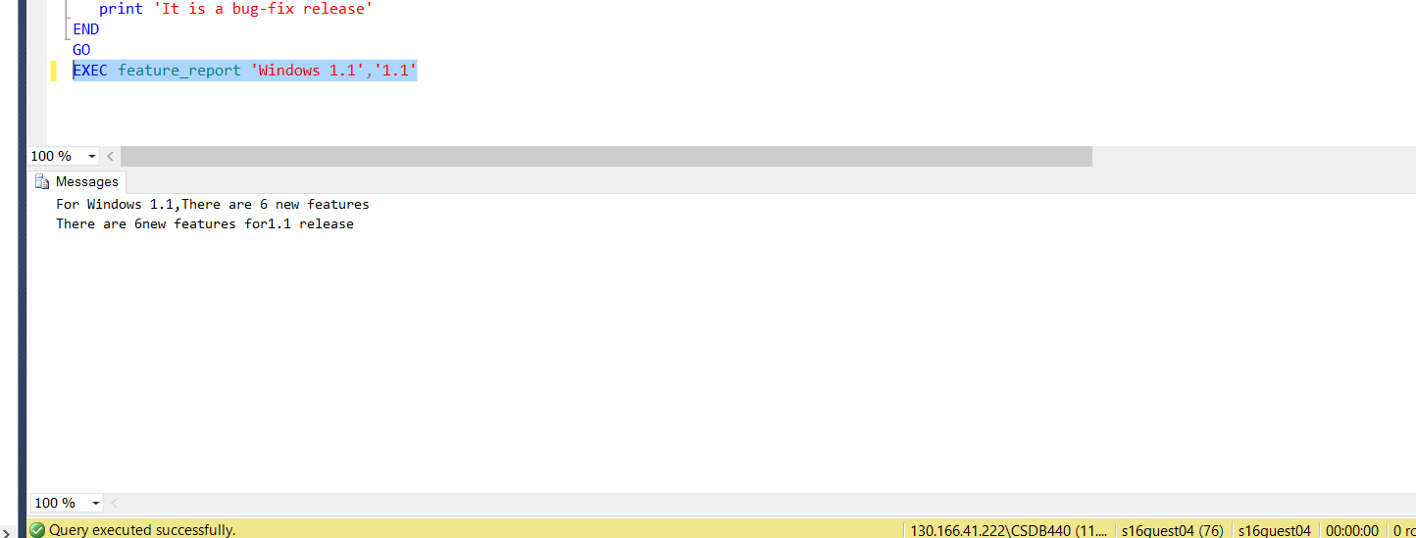

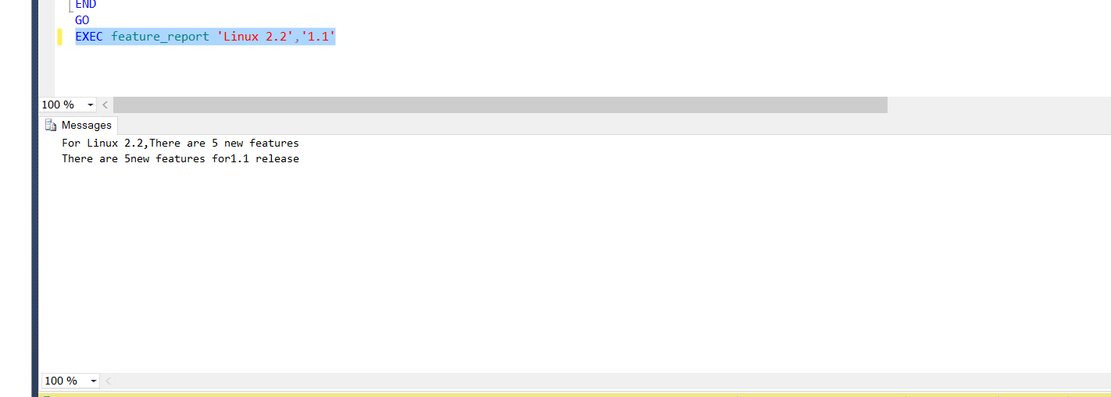

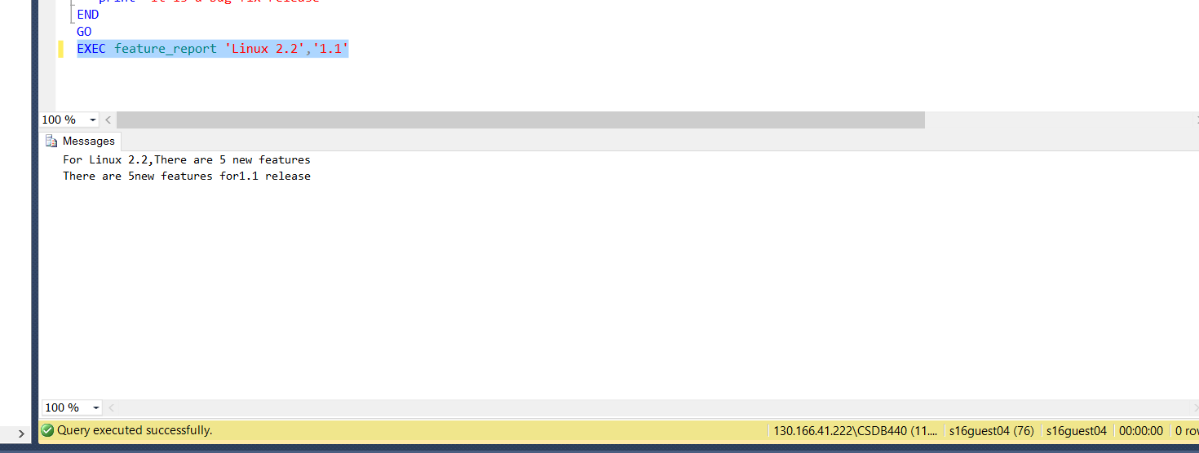

**Bugrelease**

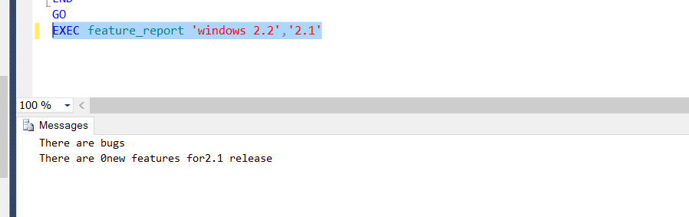

5)Source Control

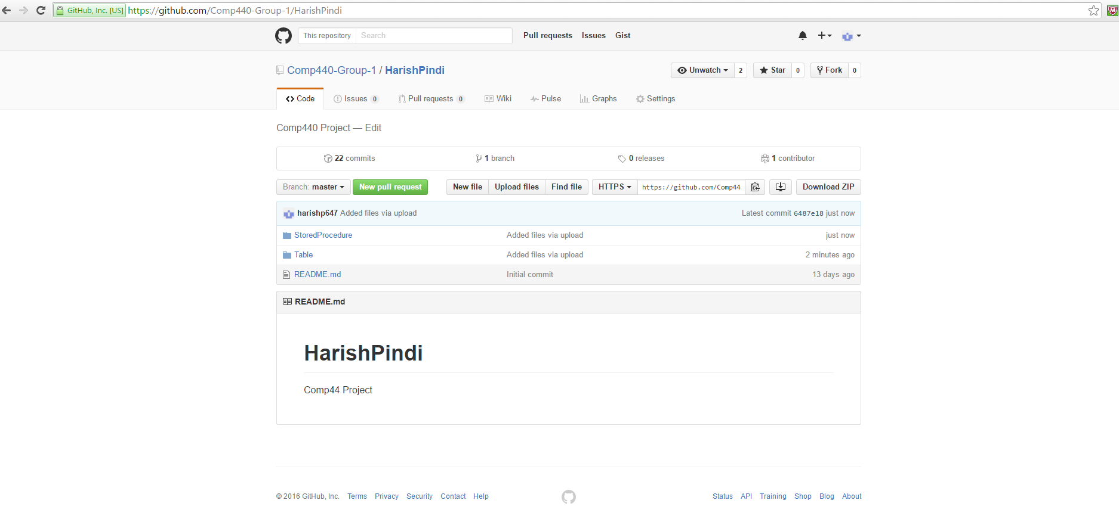

**6)Diagram**

